CS590BD Big Data Analytics and Apps

**LAB - 4**

**Training, Testing Motion recognition and save the retrieval file and performing file transfer operations**

**By**

**Ponnam Balakrishna**

**16177831(BP8G6)**

**Motion recognition webservice Training and Testing:**

For training and testing the motion recognition we need the input files which is collected with the data.

Those data file is generated from the android application by connecting to the sensor tag and collect the required data by running the android application.

In the application we have the UUID tags which connect to the sensor tag.

The below screen shot shows the UUID tags:

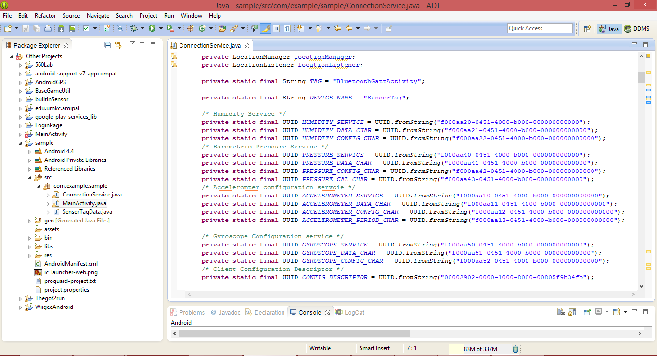

And in the code it we need to specify which data we need to specify. And need to enable that service in the sensor tag. By selecting any of these devices it open some of the sub tasks and by selecting those it gives the values of the particular selected item.

After enabling that service and connecting to the sensor tag there in the code it collects all the data required and writes into a text file.

Those text file which is created can be downloaded by installing ASTRO FILE MANAGER application and in that app there is a data folder where the text file is saved.

Those text file contains the data which you enabled and each service data is separated by the given field saying tab space or comma or full stop etc….

The below screen shot shows the different cases where the program enters each loop and collect the required data of the particular service.

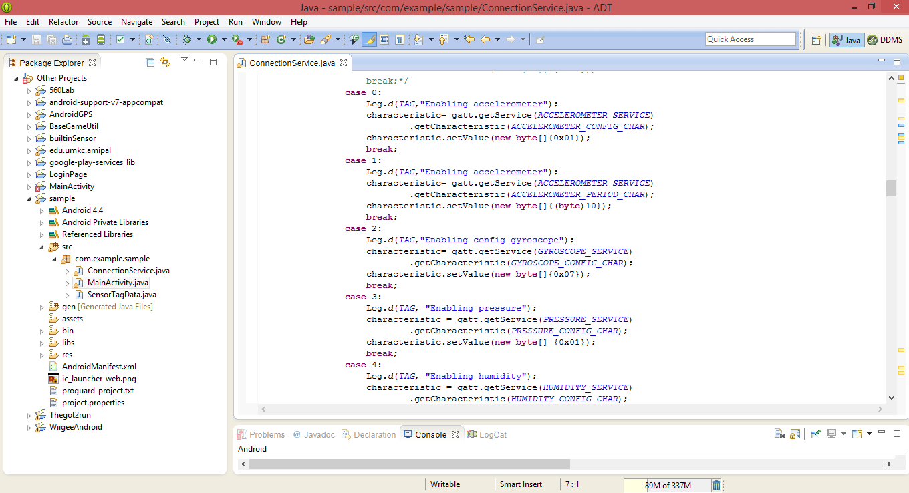

The below screen shows the collected data from the sensor given with the tab spaces for each value

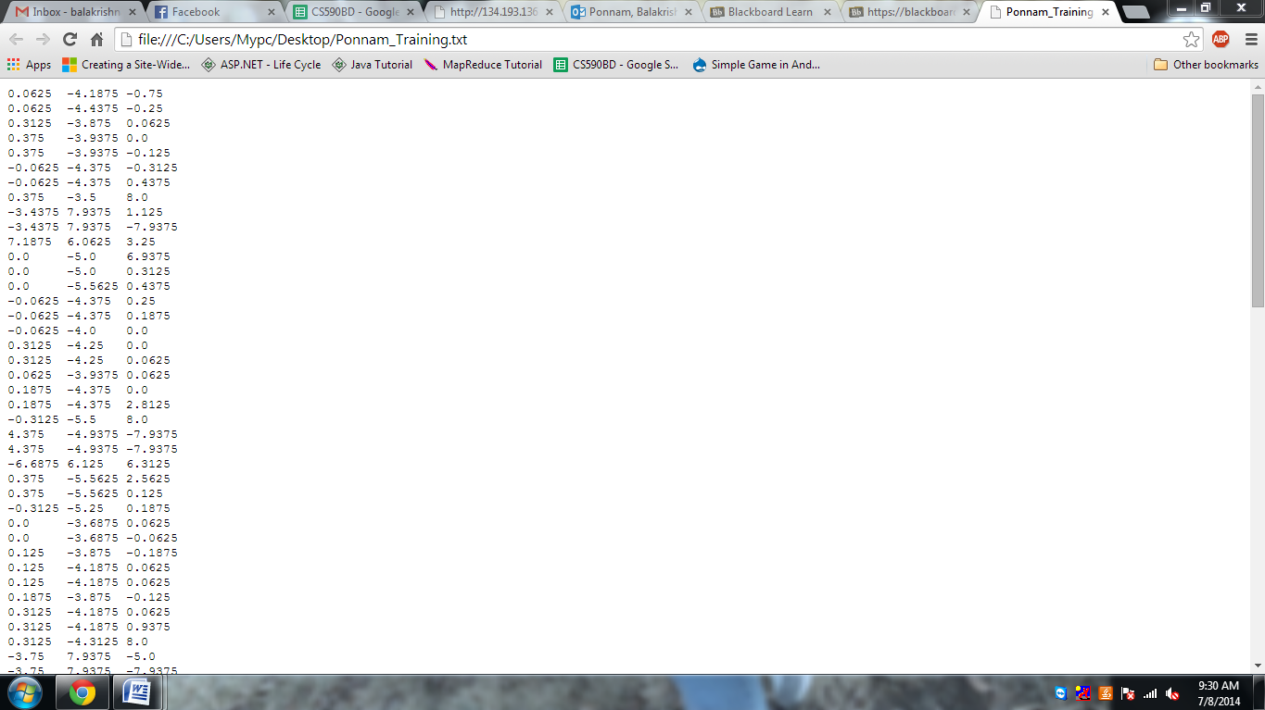

Those collected data is used for training and testing which generates a sequential file of the particular pattern.

For training and testing need to create two files and then need to transfer those files remotely by using the Putty or Secure Shell File Transfer

The below screen short for connecting remotely using secure shell file transfer:

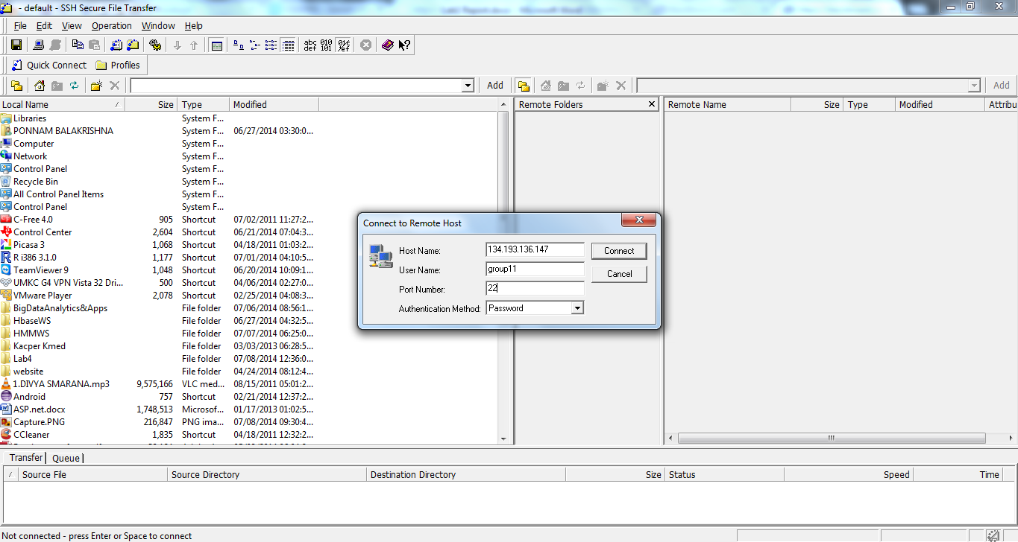

After giving the host name and the group to which we need to connect. Then press connects, and then it asks for the password. After connecting to the host it displays the our space of group remotely

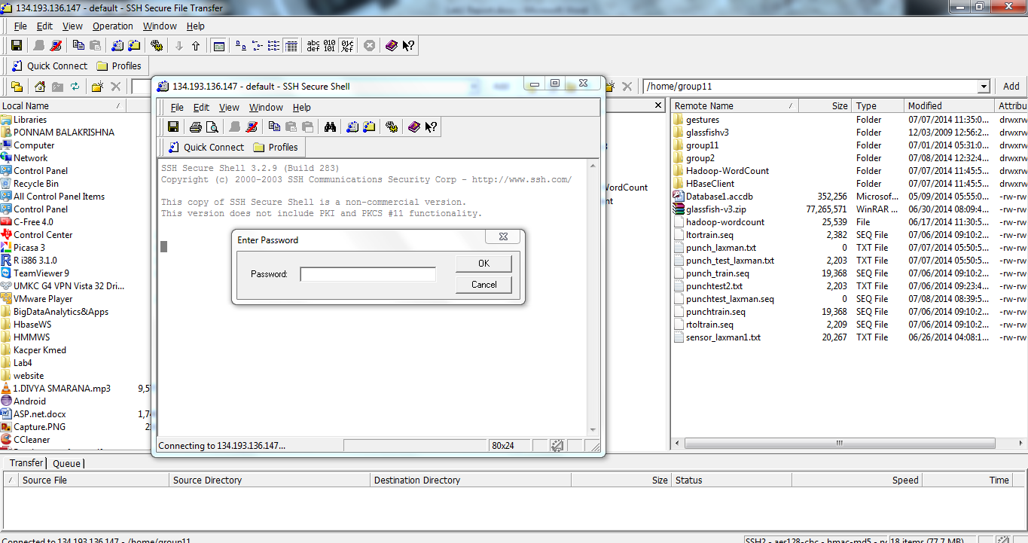

Then drag and drop the files which need to be trained and tested

The below is the screen short after transferring the files:

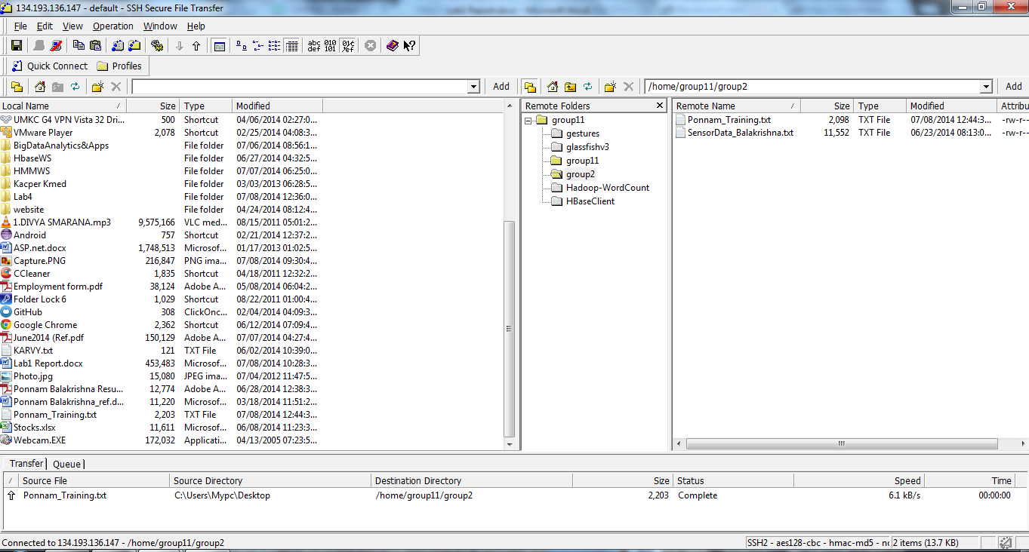

Then for training and testing access these files and give this path to generate a sequential file

If the data has multiple services then we need perform the operation several times which indicates no of services we have those number of times we need to perform the operations

<http://134.193.136.147:8080/HMMWS/jaxrs/generic/TrainFileOperation/punchtrain.txt/punch.seq/>

In the above url punchtrain.txt is the data file which need to be trained and punch.seq is the sequential file which will be generated after training that text file.

If we have multiple actions to train then need to do multiple times

<http://134.193.136.147:8080/HMMWS/jaxrs/generic/TrainFileOperation/punchtrain.txt/punch.seq/>

<http://134.193.136.147:8080/HMMWS/jaxrs/generic/TrainFileOperation/left2right.txt/left2right.seq/>

<http://134.193.136.147:8080/HMMWS/jaxrs/generic/TrainFileOperation/right2left.txt/right2left.seq/>

After performing all those training operation then we need to perform the testing operation

The testing operation can be performed by executing the following url

<http://134.193.136.147:8080/HMMWS/jaxrs/generic/TestFileOperation/-home-cloudera-punchtest2.txt/-home-cloudera-punchtest.seq>

The below is the screen and sequential file data for the above were the sequential file is generated:

